AN LAC SEAFOOD CO., LTD. (HK216)
Lot A14, 4A Street, Hai Son Industrial Zone, Duc Hoa District, Long An Province, Vietnam.
Tel.: 84-72-3850606 Fax.: 84-72-3850608.

No.: 03/2011/ALC-SFC
STATEMENT
TO.: SHUNG FON CO., LTD.
DATE | INVOICE NO. | AWB | TOTAL
14 MAR. | 03/2011/ALC- SFC | 695 3339 4152 | 17,259.39
TOTAL INVOI 01+02 |  |  | USD 16,453.48
GRAND TOTAL |  |  | USD 33,712.87
DEPOSIT1 |  |  | USD 15,000.00
DEPOSIT 2 |  |  | USD 20,000.00
REMAIN |  |  | USD - 1,287.13
Says: US DOLLARS One Thousand Two Hundred Eighty – Seven And Thirteen Cents Only.
AN LAC SEAFOOD CO., LTD.
- Account No. : 1015 148 5100 9193
- Name Of Bank :EXIMBANK DISTRICT 11 BRANCH, HOCHIMINH CITY, VIETNAM.
- Swift. EBVIVNVX11D
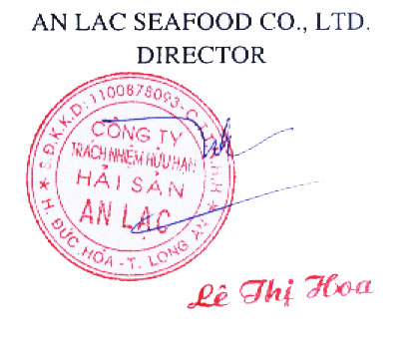
- BENEFICARY: AN LAC SEAFOOD CO., LTD.

